**Programming Project**

***Rhythm Game:***

***Tap Mania***

**Jason Ye**

**All Saints Sixth Form College**

**34307**

**Contents**

**Analysis** 2

*Outline of Project* 2

*Key Requirements* 3

**Stakeholders** 3

*1.* *Abinayan Vigithbabu – Client* 3

*2.* *Liam O’Grady – Tester* 3

*3.* *Saimen Wu – End User* 3

**Target Audience** 3

**Computational Methods** 4

*Thinking Abstractly* 4

*Thinking Ahead* 4

*Thinking Logically* 4

*Thinking Concurrently* 4

*Decomposition* 4

*Problem Recognition* 5

*Thinking Procedurally* 5

*Research* 6

*Hardware and Software Requirements* 9

*Success Criteria* 9

**Design** 11

*Top-down Design* 11

*Breakdown of my Top-down design* 11

Main Algorithms 19

Test Data for Development 27

Testing Data for Robustness 31

End User Survey 32

Development of the Coded Solution 33

## **Analysis**

## Outline of Project

The game that I will be creating for my programming project will be a Rhythm game. This game will be generally targeted for people whom may have an interest in games such as Guitar Hero, Osu, Taiko and etc. Many rhythm games have already been created; however, I would like to implement my own ideas into the game and potentially making an even better product. The way that players will progress in the game is by getting used the speed, landing perfect hits, getting combos and I will add in difficulties to increase the beat and rhythm so that the players can be challenged even further. For my rhythm game, I could add extra functionalities such as a leader board, score, adapt it to a different design and a log-in screen.

## Key Requirements

The requirements for my Rhythm game – Tap Mania – includes a target audience of 8+ year olds as it may be too difficult for younger kids to play, however, they are free to play it if they wish as it is not an 18+ game with violent/sexual content. I will complete this by creating a sign-up page with users and agreements included in it as well. Another requirement for my game will enable the players to use the keys ‘S’, ‘D’, ‘J’ and ‘K’ to tap on to the rhythm notes, I could also add in a feature that allows the users to configure the keys to their preferred likings if needed.

# **Stakeholders**

## Abinayan Vigithbabu – Client

Abinayan will be the one that I will be producing ‘Tap Mania’ for. The first stakeholder will be a 17-year-old student that is attending the same college as me, he is a very competitive gamer who loves to purchase and try out new games. Abinayan will be able to assist me throughout the project by pitching in extra ideas for the game and returning honest feedbacks to whether the game is suitable for.

## Liam O’Grady – Tester

The tester is somebody that will be testing each feature of ‘Tap Mania’ to decide whether the game works suitably at a professional standard that will meet the audiences’ likings. Liam O’Grady is going to be my second stakeholder; he also attends the same college as me; All Saints Sixth Form College. Liam will be able to ensure that my project will always stay at a steady pace as he is able to give out useful advices from my experience. Liam O’Grady is the perfect election for this role as he is very intellectual and can decipher a problem very well. By having Liam to test out all of the features of my game, this will enable my game to reach its highest potential.

## Saimen Wu – End User

The end user is another person that will test to see if my game is able to meet all the given requirements and is entertaining enough to play on. Saimen Wu will be my third and last stake holder, he is also a student attending All Saints Sixth Form College, he enjoys playing challenging rhythm games such as Osu, Piano Tiles and Deemo. He will be able to compare and give advices to how I can improve my game since he has a good knowledge of many rhythm games. Saimen will definitely be an ideal end user for my end product as he will be able to pick out the key details of my game.

# **Target Audience**

As mentioned earlier in the outline of my project, the target audience will be aimed at people whom already has an interest in rhythm games. I would also like to target my game at people who likes to listen to music as well since the game allows them to listen to the song and also interact with the beat of the song therefore making it more exciting and fun for the player. Furthermore, having college students to be my stakeholders will allow my product to be more accurate as they will give out advice that is more precise as it will be directly from a students’ opinion.

# **Computational Methods**

## Thinking Abstractly

For the graphics of the game that I will be using, it will not be too complex as the game centres around the mechanic of the game more than the graphics, however I would like the graphics to be easy-to-see and also made to a professional standard. There is not much requirements for significant detail for the rhythm notes as it will only be a rectangular block. The game should realistically look more appealing as rhythm games are normally quite creative and aesthetic due to the game is being based of music which is a form of art that can be conveyed in, however I do not think that I will be able to generate high level graphics due to the lack of experience, but I will create it as best as I possibly can with the resources I have.

## Thinking Ahead

The inputs will definitely include the controls for the player to tap on the rhythm notes as that is the main mechanic of the game. The player can hold on to the keys to hold on to the streak of note, or tap the key once to complete the note. The notes will be appearing from the top of the screen therefore giving the player time to know when and which finger to use to click on to the notes.

## Thinking Logically

From my knowledge, my game will be coded with many IF-Statements, for example, the player playing Tap Mania, will have the option to press either ‘S’, ‘D’, ‘J’ or ‘K’, however they may change the keys if they like. The player may increase the difficulty by going to main menu, press ‘play’ and then select either ‘easy’, ‘medium’ or ‘hard’, this is to ensure that the game will not be too difficult or easy for the player as all of the players will have different talents. If they player fail to keep their HP bar above 0HP then it will be GAME OVER, therefore they will be able to either restart the game, quit or select a new difficulty.

## Thinking Concurrently

During the gameplay of Tap Mania, the program must ensure that it will be able to keep track of the player’s score, health, time and multiplier. The multiplier will differ depending on how the player is performing, and if the player is missing notes, their health will start to decrease and once the HP bar reaches 0, the game will be over. The program will also make sure that the correct sound effects are being played throughout the whole song.

## Decomposition

There is a large amount of sub-problems that my program can be divided into which would be effective for me to do in order to make the development process easier and less complicated as the problem will have been broken down into smaller bits. The problem that will be solved becomes much more manageable and accomplishable.   
These sub-problems may include:

1. Adjusting the gameplay based on the difficulty chosen.
2. Configuring the settings within the game to fit the player’s needs.
3. Making sure that the hitboxes are in place for the notes.
4. Aligning sound effects with different events that may occur during gameplay (e.g. missed, early hit, perfect hit, late hit)
5. Spawning notes at a faster speed depending on the difficulty
6. HP bar increasing/decreasing as the player may miss some notes.
7. Calculating the score along with the multiplier.

## Problem Recognition

The problem that I will be able to solve seems achievable; the game must be able to provide entertainment and enjoyment for extended periods of time whilst keeping the classical experience of similar features intact. There should be a way that each round the player goes through feels different each time which could potentially be accomplished by giving the user the option to choose different songs. This will prevent the player from becoming bored of the same song and beatmap every time and therefore leading to a higher chance of a positive outcome. Furthermore, the program itself should be efficient enough to run on older specification computers without any issues as this game will not be graphically intensive, nor will it need a powerful CPU.

## Thinking Procedurally

The game will include the following:

1. Main Menu – The logo is present on this screen and the player can choose to change the game’s settings and difficulty, they will be able to view the leader boards, they will also be able to have the option to sign-up/log-in to the game, they can quit the game or directly go into the gameplay itslef.
2. Settings screen – The player can change the brightness, alter the sound settings (e.g. audio and sound effects), set the game to full screen and also change the key bindings to suit their needs.
3. Leader boards screen – The player can view the names of the players who have achieved the highest scores which will be updated each time a new player reaches a higher score.
4. Playing field – The main body of the program which allows the player to interact and play the game.
5. Game Over screen – This is the screen that will be activated when the player’s HP bar depletes to 0, they will be able to view their score which they can save to the leader board if they choose to, retry/quit or return to the main menu if they choose to change some settings or a new difficulty.

## Research

**Osu Mania**  
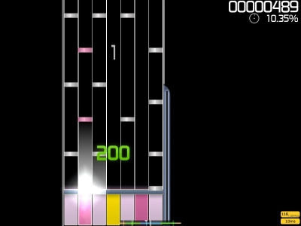

Osu Mania is a free open-source rhythm game that was created by Dean “peppy” Herbert and was released in 2007. Osu Mania was originally released specifically for Microsoft windows, however it was also ported to macOS as well. Its gameplay is entirely based on titles such as Tatakae! Ouendan, Elite Beat Agents, Taiko no Tatsujin, Beatmania IIDX and DJMax. Osu Mania also has an active esports community and is usually recommended by professional players of various different esport games to practice or warm-up their hand movements.

The game is played with beatmaps, beatmaps consist of three objects arranged in different positons on the screen and in different points of time. The beatmap is then played with accompanying music, simulating a sense of rhythm as the player interacts with the objects to the beat of the music throughout the whole song.

My game will have a similar HUD Interface as this game as this is one of the games that has inspired me to create a rhythm game for this project, I will also take in and replicate most of the functions.

**Piano Tiles 2**  


This game is called Piano Tiles 2, this is a music arcade game, created by Hu Wen Zeng. The objective of this game is to tap the black tiles without making any mistakes by tapping elsewhere that does not contain a black tile. This game contains many different songs and I want to also implement this into my game ‘Tap Mania’, however, I do not think that I will have the time to be able to implement more than 3 songs into my game as it may take too long.

Piano Tiles 2 is available on platforms such as mobiles and arcades whereas ‘Tap Mania’ will be only available on PC, however I may think about adding it to mobile apps as it may be a good idea to try and adapt Tap Mania to a mobile device.

**Guitar Hero**

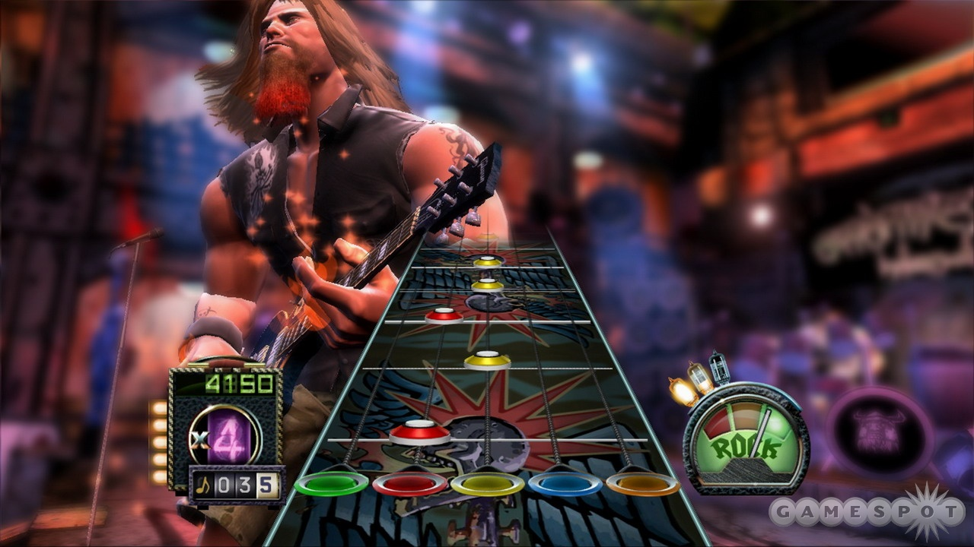  
Guitar Hero is a series of music rhythm games that was first published in 2005 by RedOctane and Harmonix, and distributed by Activision. The game is also contains a controller shaped like a guitar in which players use to simulate playing lead, bass guitar, and rhythm guitar across numerous rock music songs.

The players objective will be to match the notes that scrolls down the screen to coloured fret buttons on the controller, strumming the controller in time to the music in order to score points, and keep the virtual audience in the background excited. This game attempts to mimic many features of playing a real guitar, including the use of fast fingering hammer-ons and pull-offs and the use of the whammy bar to alter the pitch of notes.

My game will be somewhat similar to this game however, it will not have a controller that will be shaped like a guitar as my game is not based off a guitar but rather just focusing more on the a piano-like gameplay.

**Stepmania**

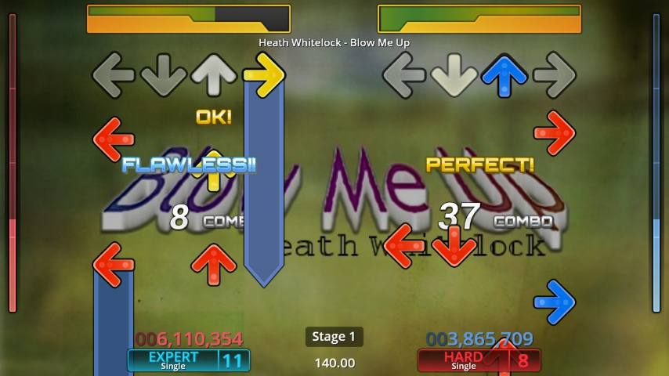

Stepmania is a cross-platform rhythm video game. It was originally developed as a simulator of Konami’s arcade game series ‘Dance Dance Revolution (DDR)’, and has since evolved into an extensible rhythm game engine capable of supporting a variety of rhythm-based game types.

The primary game type features the following gameplay: as arrow scrolls upwards on the screen, they meet a normally stationary set of target arrows. When they connect, the player must press the corresponding arrows on their keyboard or dance mat. The moving arrows meet the targets based on the beat of the song, which I also intend to do for my game ‘Tap Mania.’

The features within this game ‘Stepmania’, includes a lot of functions that I am planning to add to my game as that this my primary idea from the start.

**Taiko No Tatsujin**

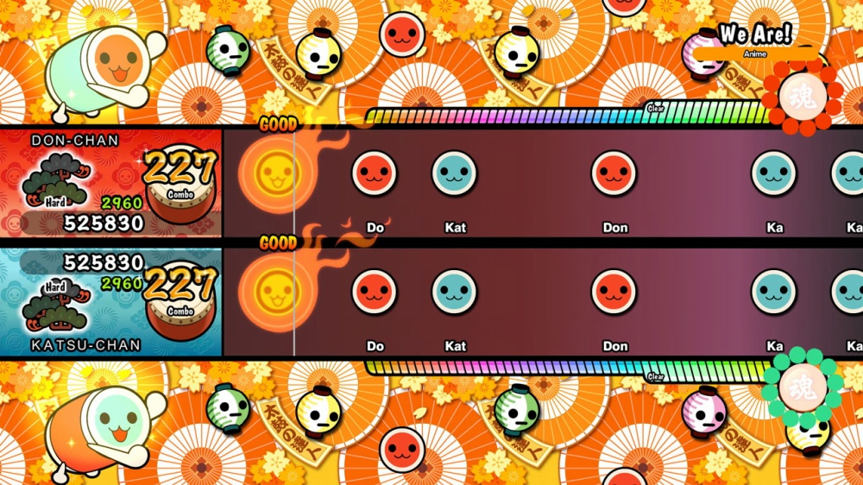

Taiko no Tatsujin is a series of rhythm games created by Namco. In the games, players simulate playing a Taiko drum in time with music. The series has released games for the arcade and for console and mobile platforms.

The main objective of this game is to hit a simulated Taiko drum following a chosen piece of music, corresponding to notes as they scroll from the right to the left. The game uses simulated Taiko, which register hits when played with drum sticks (bachi), this is to simulate the feel of being a Japanese Taiko master hence the name of the game ‘Taiko Master.’

The feature that I may implement into my game may include are the user interfaces as they are really colourful, fun and engaging with the player.

## Hardware and Software Requirements

**Hardware:**

* A mouse will definitely be needed to interact with buttons on the menu of the game.
* The keyboard is used for the player to time their clicks in order to hit the notes that will be dropping down from the top of the screen.
* According to Unity’s website, any graphics card with DX9 capabilities will suffice, but it depends on the complexity of the finished product, in my opinion the game will not be graphically intensive therefore it should be fine as my game will most likely be using the 2D components in Unity’s engine.
* Unity also suggests a CPU with SSE2 Instruction Set Support which is the minimum processing power required to run any Unity game.
* A monitor with a resolution of at least 1920x1080 will be needed as my game will most likely be based off those proportions.

**Software:**

* Unity can run on Windows Operating systems from XP onwards, this means that anything older than Windows XP will not be able to run Unity as that is the bare-minimum.
* Unity is not needed to be installed on to your PC to play the game, the game will be played in a separate, generated application that does not require the game engine.

## Success Criteria

Programming

1. All of the variables should be named in accordance to set rules such as the use of underscores for multiple words in one variable and beginning with a lowercase letter, you may also use uppercase letters on the separate words. This will make my variable easier to distinguish and use as part of the program’s functions, as well as use appropriate scope for more efficiency and better presentation.
2. Furthermore, throughout the implementation process, I must always decipher means to keep the code as efficient as possible, this may be the use of recursion, if statements for larger arrays of condition and sub procedures.

The Game

1. The game should be able to be accessed easily by the user, this can be done my implementing a shortcut to the game which can allow the user to open it without any hassle and interruption therefore making it more user-friendly.
2. The score should be updated each time the user scores a hit on the note which allows the user to know what they are currently scoring.
3. The user interface should be designed to a good quality so that the user enjoys what they are interacting with, this is so that the game designs are eye candy to the user and is pleasant to be used.
4. The notes should be sliding down from the top to the beat of the song, so that the user can hit the notes with comfort, this allows them to enjoy the game even more because it will be in rhythm to the song that they are currently playing, if it is off-rhythm, then they will struggle to play along to the song.
5. The keys that they click on must be responsive otherwise there will be no point in the game, as this game is all about reaction time and speed, if the player does not get rewarded for their speed, then the game will be very unlikely to be played by other people.
6. High scores should be written to a leader board next to an entered name and the positions should be updated as accordingly if one score is high than the other. This may allow the player to set a goal to work towards therefore enabling them to become more competitive about the game, which makes the game even more enjoyable.

# **Design**

## Top-down Design

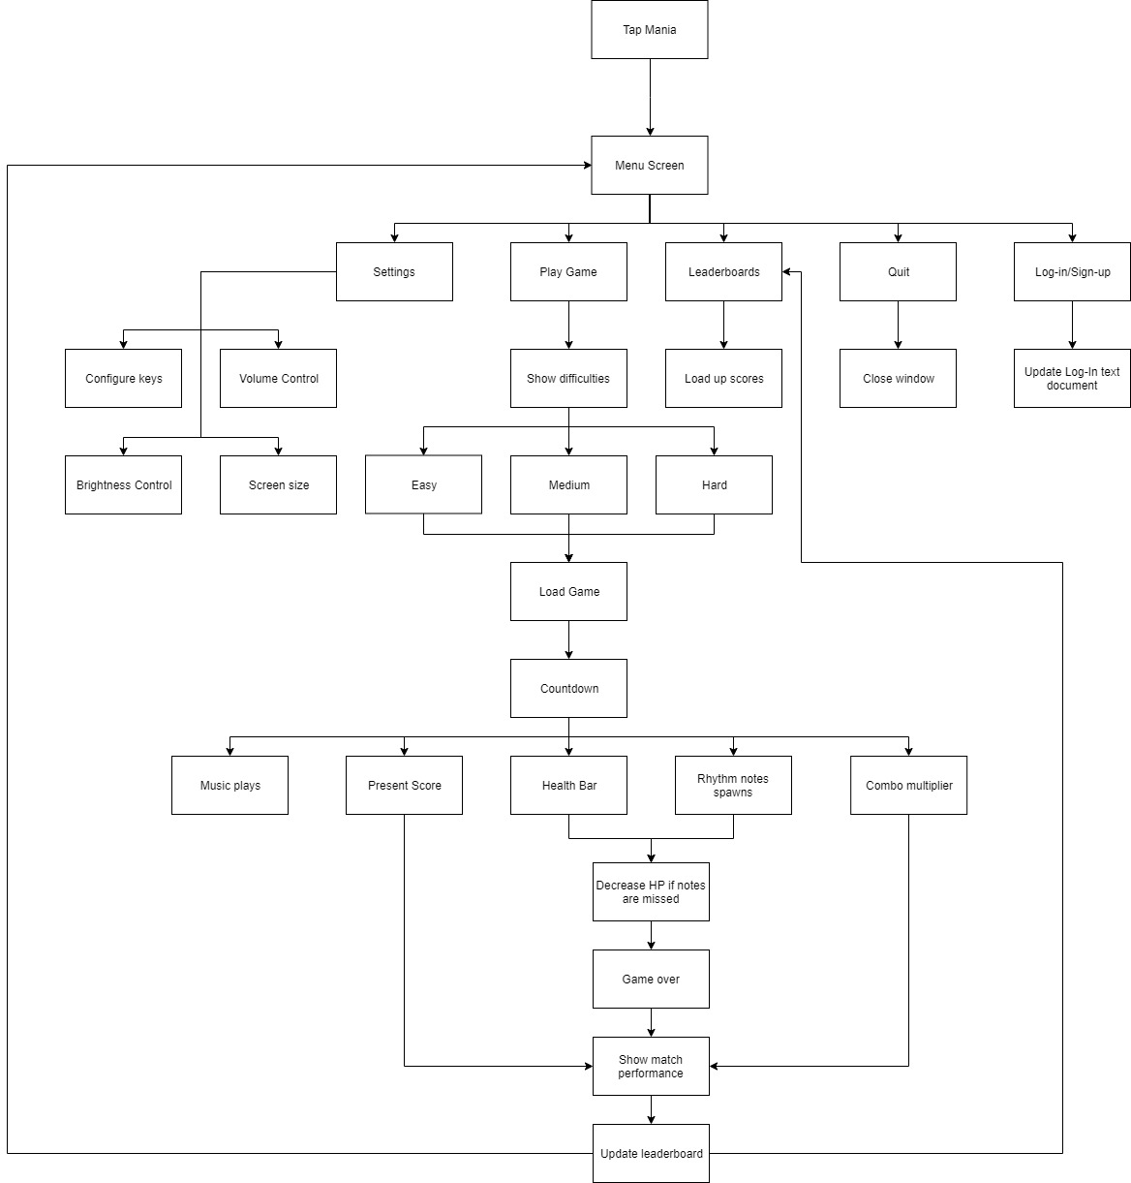

## Breakdown of my Top-down design

There are five problems that will trail from the menu screen: Settings, leader board, quit, log-in/sign up screen and also playing the game. These functions will need to be accessible once the player loads the game up.

**Settings**

The settings are further broken down into ways that the main game can be changed in terms of sound, resolution, key bindings and brightness, these are all important sub-problems that should be looked into as they will allow the user to adjust the settings to their needs. They will be able to lower/higher the volume as the default volume may be too quiet/loud for them therefore adjustments will be needed.

**Main Game**

In my game, there will be 3 levels/difficulties; easy, medium and hard. This will allow the players to choose the difficulty they are most comfortable with and enjoy whilst tapping to the rhythm of the song. Under the countdown category are sub-problems related to playing the music, showing the score, health bar, multiplier and spawning the rhythm notes.

The controls of the player will depend on the settings, there will be different algorithms required for the player’s key bindings as they may change it beforehand in the settings screen, however, the default keys will be ‘D’, ‘F’, ‘J’ and ‘K’. I have used these keys because it allows the players to have a small spacing between each hand therefore enabling them to play comfortably.

During the gameplay, the player may miss some notes therefore his HP will decrease, however, they can regenerate their hp back by clicking on each note without missing, this will steadily allow them to regenerate their hp back. During the process of the main game, the player’s score will also increase (assuming that they are able to complete the difficulty), and whilst it increases, the combo multiplier will also come in to increase the player’s score massively depending on the combo.

**Game Over**

When the player’s HP depletes to zero, all functions in the main game will be halted and the player will be directed to the game over screen. The player will be able to choose whether to return to the main menu, quit the game or retry the same difficulty again. The scores will automatically be saved to a csv file; its position on the csv will depend on the score as the more it is, the higher it will be on the rankings list. This will involve sorting the order of lines in the file based on the largest score first.

**The initial layouts for each screen of my game are shown below**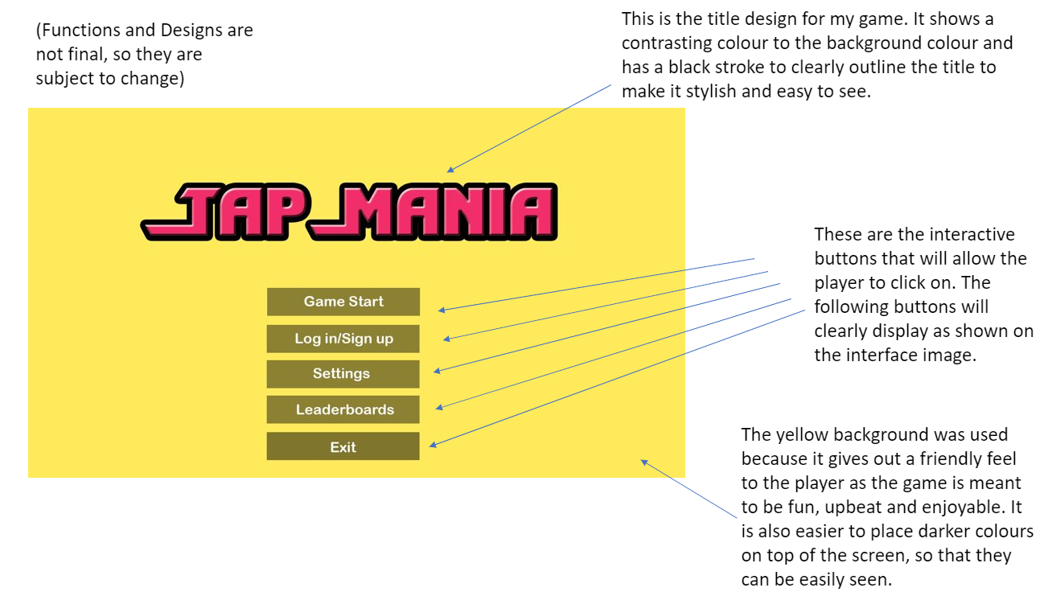

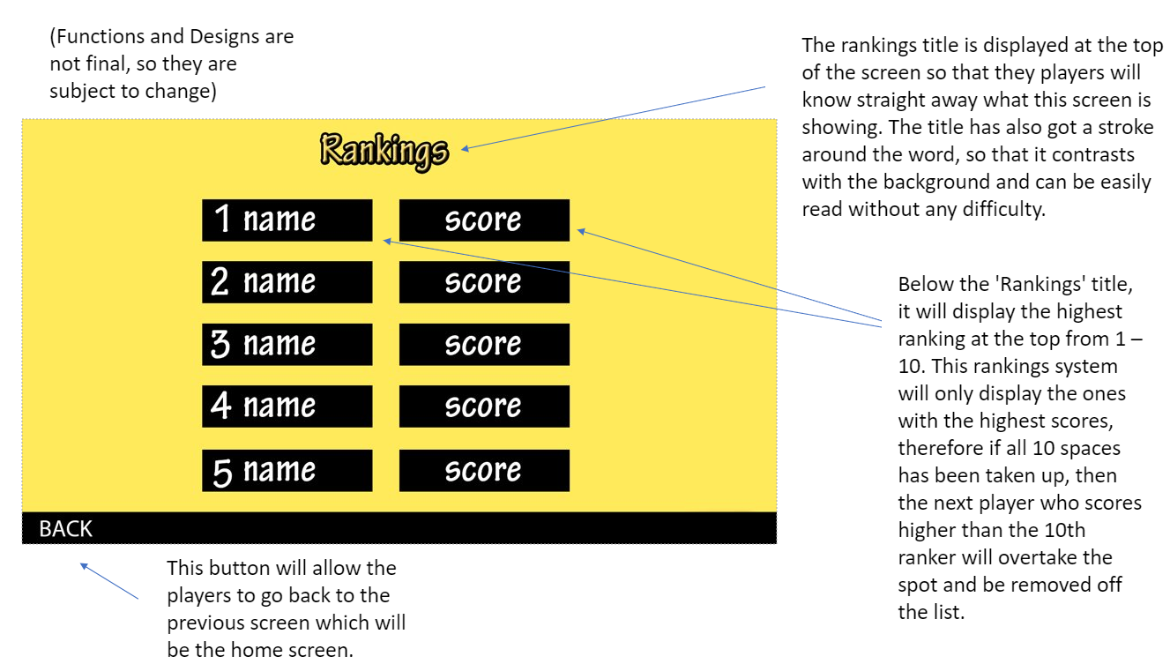

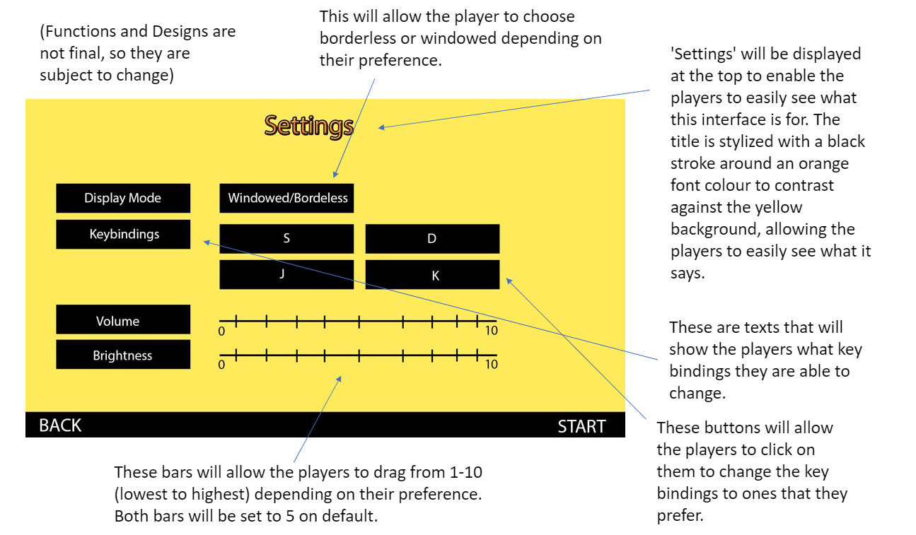

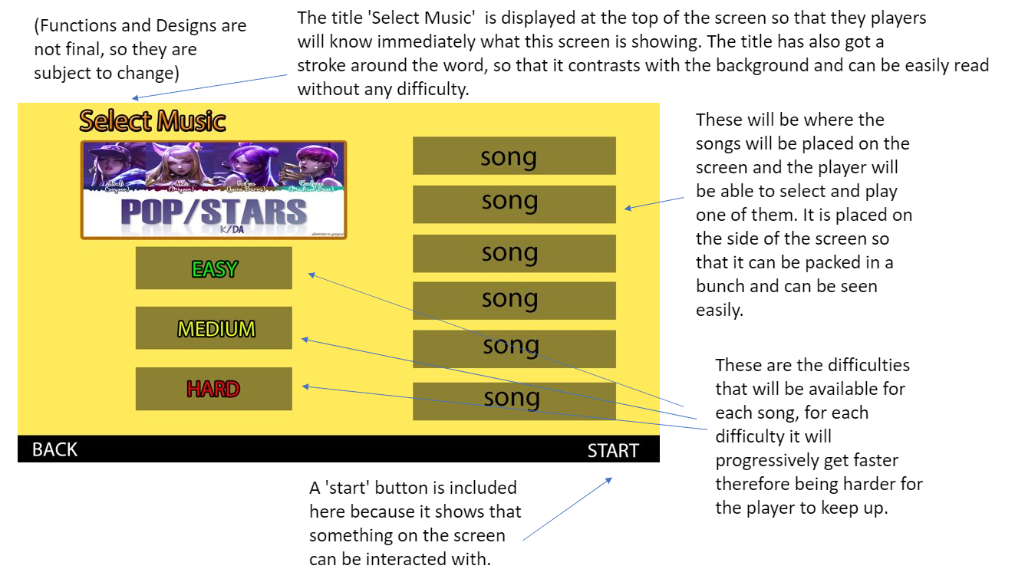

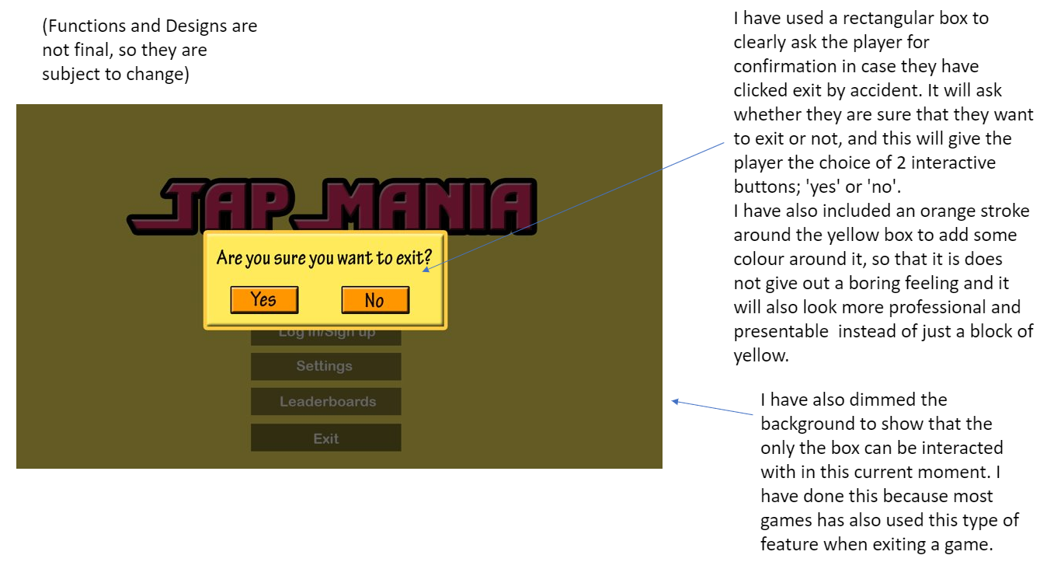

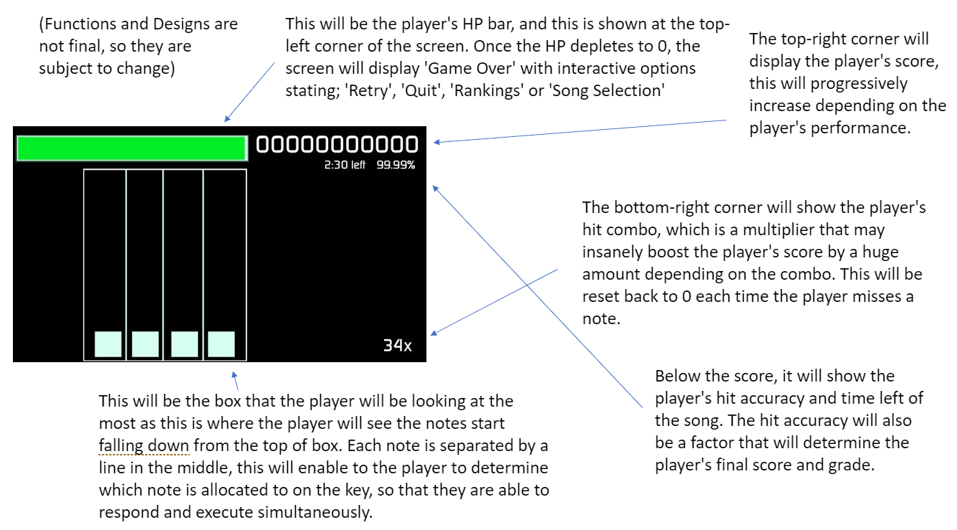

**Data types and Structures for the Home Screen**

|  |  |  |  |  |
| --- | --- | --- | --- | --- |
| Form | Name | Data Type | Purpose/Justification | Estimated Values |
| Home | startGame_Home | Boolean | This will just be a button that will be available to the player when he wants to play the game as there will be a selection of buttons in the home screen. | True/False |
| Home | leaderboards_Home | Boolean | This button will enable the user to see the high scores that players have scored ranking from highest to lowest. | True/False |
| Home | settings_Home | Boolean | This button will allow the user to go into the settings and configure them if they intend to do so. | True/False |
| Home | exit_Home | Boolean | This button will allow the user to be able to exit the game whenever they are finished playing the game. | True/False |
| Home | logInSignUp_Home | Boolean | This button will allow the user to either log in or sign up to the game so that it allows them to save their score to the leaderboards. | True/False |
| Home | Validation_exit_Home | Button | This button will show up right after the user has clicked exit to make sure that the user did not make a mistake and that they are sure that they are quitting the game. | True/False |

**Data types and structures for the Rankings Screen**

|  |  |  |  |  |
| --- | --- | --- | --- | --- |
| Form | Name | Data Type | Purpose/Justification | Estimated Values |
| Rankings | BackHome_Rankings | Boolean | This will just be a button that will be available to the player when he wants to return back to the home screen. | True/False |

**Data types and structures for the Settings Screen**

|  |  |  |  |  |
| --- | --- | --- | --- | --- |
| Form | Name | Data Type | Purpose/Justification | Estimated Values |
| Settings | Screen | Boolean | This will just be a button that will be available to the player for if they want to change the screen type to either windowed/full screen. | Windowed/Full Screen |
| Settings | Keybindings | Variable | This will be an option for the user to click on in order to change the types of keys that they would like to like use to play the game. | Any sensible keys |
| Settings | Volume | Integer | The user will be able to edit the volume by dragging the scroll wheel which is set as values of integers. | 1-10 |
| Settings | Brightness | Integer | The user will be able to edit the brightness by dragging the scroll wheel which is set as values of integers. | 1-10 |
| Settings | Back | Button | The user will be able return back to the home screen to select a different option such as ‘play’. | True/False |

**Data types and structures for the Song Selection Screen**

|  |  |  |  |  |
| --- | --- | --- | --- | --- |
| Form | Name | Data Type | Purpose/Justification | Estimated Values |
| Song Selection | Difficulty_Song_Selection | Button | The user will be able to select from difficulties between Easy, Medium and Hard which will be similar to a checkboxes. | True/False |
| Song Selection | Song | Button | The user will be able to select a song that is going to be shown on the right side of the screen, this will also be similar to checkboxes. | True/False |
| Song Selection | BackHome | Button | This will allow the user to go back to home screen which will give them options to look at things | True/False |
| Song Selection | StartGame | Button | The user will be able to start the game right after choosing both a song and difficulty. | True/False |

**Data types and structures for the Game Screen**

|  |  |  |  |  |
| --- | --- | --- | --- | --- |
| Form | Name | Data Type | Purpose/Justification | Estimated Values |
| Game | Keys | Button | The user will be able to click on buttons that the keys are assigned to, this is so that they are able to tap on the notes that will be appearing from the top. | S, d, j and k |
| Game | arrayKeys | Array | The purpose of having an array for the player keys is that it will allow the keys to be stored into some sort of list, so that it can be changed, used and stored. | arrayKeys=[ ] |
| Game | Score | Integer | This will show the player’s current score which will change throughout the whole game. | 100000 |
| Game | Accuracy | Float | This will show the player’s accuracy of hitting the notes as these will impact on how much points the player gets per hit on the notes | 99.99% |
| Game | Combo | Character | This will show the player’s combo which is added up by continuously hitting notes without missing a note. | 33x |
| Game | Hp_Bar | Integer | This will show the player’s current health on the health bar on the top left, this will be calculated by integers. | 100/100 |
| Game | Time_Left | Character | This will show the player how much time is remaining until the end of the song. | 2:30 minutes left |
| Game | Esc_button | Button | This will pause the game and bring up a menu with options that will allow the user to either return to game, quit game or restart. | True/False |
| Game | Restart_button | Button | This will restart the game from the start. | True/False |
| Game | Quit_Game_button | Button | This will quit the game and return back to the menu screen. | True/False |
| Game | Return_to_Game | Button | This will allow the user to return back to the current game that they are playing on | True/False |

**Validation**

There will not be much validation on my home screen as most of the data types will be considered as buttons, the only validation that will come up is when the user tries to quit the game, the game will ask the user for confirmation before quitting the game as they might have clicked on it by accident and it will be inconvenient for the user to start the game back up as it may take some time.

There will not be any validation for my rankings screen because there is only one button and that is to go back to the home screen.

The validation that will be needed in my settings screen is when the user changes the key bindings, a pop-up screen will ask them if they are sure that they want to change the keys.

The validation that would be needed in my song selection screen is when they start a game, the player must choose a song and difficulty before they are able to start the game otherwise the game will not continue until they have chosen one each.

There will not be any validation needed for my game screen it is all buttons therefore validation is not needed due to the simplicity of the feature.

## Main Algorithms

**Menu**

For my main menu, it is very important that the menu buttons and functions will work as expectedly as they will need to take the user to the correct screens respectively. I will have multiple buttons for my main menu screen; Game Start, Log In/Sign up, Leader board, Settings and Exit. Each time a button is clicked on, the game will output a sound effect that will sync with the time that the button was clicked on to make it fun and interactive for the user, not to mention, the game will also have existing music playing in the background to keep the play interested as not having music will bore the player.

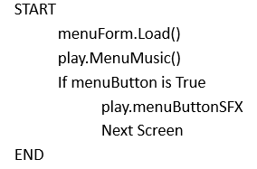

Furthermore, Unity Game Engine will have some functionality that allows the creation of a form by dragging and dropping the components that are provided in the library, this will allow me to edit their properties etc without having the need to necessarily write the code from scratch therefore loading individual buttons and graphics should not be generally concerned. The second line allows the game to import an audio file and play the music on a loop so that it never ends, this will necessary since my game is linked with rhythm and music therefore having a music in the background would be a sensible and suitable idea in the menu screen, however I may not need to write the code for it from scratch as Unit already provides function that will allow you to drag and drop on to the game which will make it easier for me to import in.

**Settings**

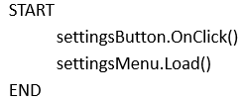

Furthermore, Unity’s IDE may allow me to drag and drop components, the settings menu could be loaded in in a similar format to the menu as the game is being started up, and this is because the functions will all need to be loaded in before the users can interact with them. The load function will load up all of the settings that are included within the game, for example the function will load up sliders for the game volume, key bindings, display mode and brightness.

**Leaderboard**

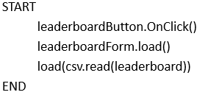

To load up the leaderboard for my game, I will be using a similar function to the previous two, however this time I will be loading up a csv file and have the program to list out all of the players and scores from ‘leaderboard’. The pseudocode will assume that the csv file for the leader board is saved in the same location as the game’s structure to reduce the need of specifying a file path, but that may be subject to change.

**Music Volume**

The main game will load after certain conditions are met, these may include being from adjusted settings, so in my opinion, I should create several subprograms to alter the volume of the main game and sound effects using parameters set by the player from the settings menu.

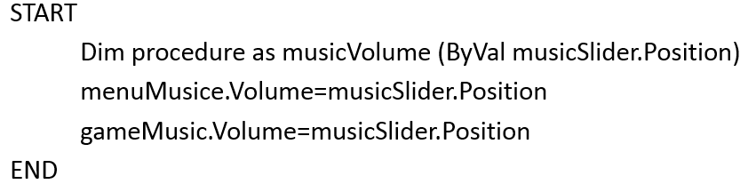

In this pseudocode, this procedure has been designed to change the volumes of all background music. Unity has an in-built volume property for every audio source, this will be very useful for me as it will make it easier to create multiple volume sliders for my game.



**Sound FX Volume**

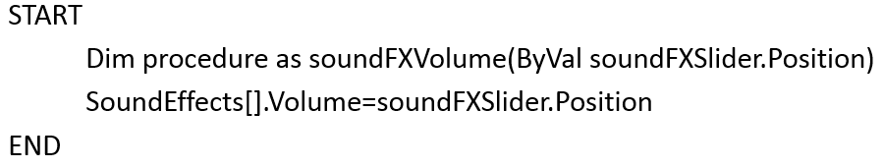

This pseudocode above that I have created, will be a separate procedure to the previous volume slider procedure because the volume of the background music and sound effects are both independent from each other. These will include a number of different unique sound effects, these will usually highlight the buttons being interacted with which will then output a sound effect for the user, for example, in my game ‘Tap Mania’, when the player is tapping on the music notes, a sound effect will be outputted from each interaction, depending on how the player has performed on the note, the program will output a specific sound, for example, there will be three types of grade for how well you react to tapping the note; bad, good and perfect. Each of these variables will output its very own unique sound effect to engage with the player a lot more in order to make the game more interesting and fun. The reason why I have created a list for ‘soundEffects’ is because this will allow me to change the values of the sound effects for each variable, as mentioned before, the grades of the notes being hit.

**Exit Game**

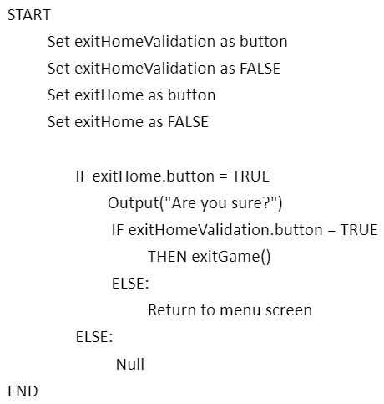

In this pseudocode that I have designed allows the user to exit the game along with validation right after clicking the button ‘exit’. I have set both variables to FALSE as buttons so that the game does not automatically exit itself otherwise the player will not even be able to play the game at all, so as the user wants to quit the game, they can click ‘exit’ then the screen will come up with a small window which will ask the user whether they want to quit or not, this will ensure that the user did not click on the ‘exit’ button by accident which will allow them to recover from that mistake. This is a reasonable function to add in because many users may accidentally exit the game by accident, and they will need to re-open the game again which will take some time depending on their computer specs.

**Back Button**

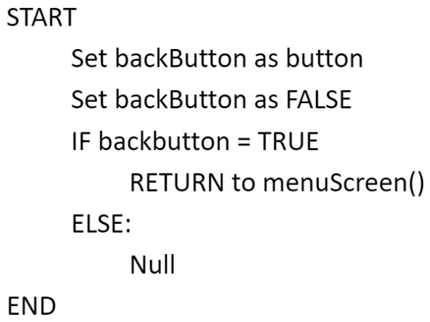

On to the next function for my rhythm game, this pseudocode will enable the users to always return to the home page which is the menu screen that contains all of the menu functions. This pseudocode will also be used a button so that when the user clicks on the button that states ‘back’, they will be directed back to the menu screen using the mensuScreen function that will have been created beforehand, this is to ensure that this can be re-used throughout the whole game, in order to save storage data, and as a bonus, it will tidy up my code therefore making it easier to identify errors and bugs. This function will not have any validation at all since it will not be necessary for the users.

**Fullscreen/Windowed**

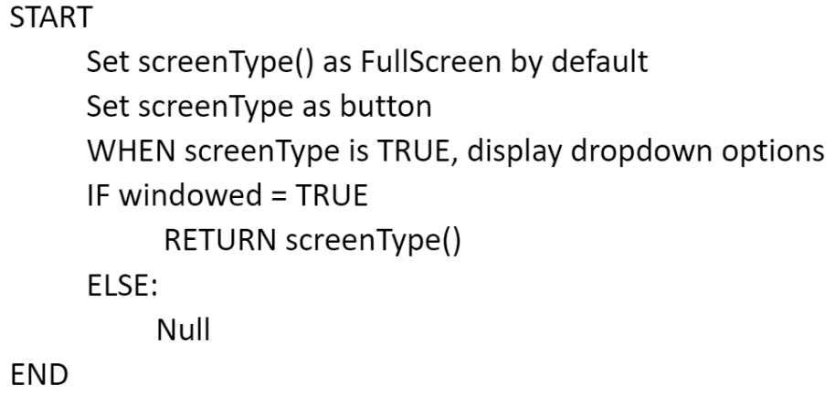

Furthermore, the next pseudocode that I have designed is for the user to select the type of screen that they want to play their game on, for example they can select either Fullscreen or Windowed depending on their preference, the game will be automatically set to Fullscreen by default so if they want to change it, they may. In this pseudocode, screenType() will be created as a list and it will set FullScreen by default, this function will be set as a button so the player can click on it and it will display options for the screen type. If the play has clicked on the other screen type, then it will return the value back to screen type, replacing the current one, else it will do nothing.

**Key bindings**

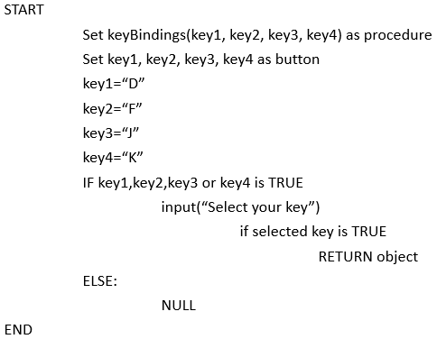

If the user wishes to change the key bindings to suit their preferences more, they will be able to do so within the settings. I have designed this pseudocode to allow the users to change the key bindings. I have set ‘keyBindings(key1, key2, key3, key4)’ as a procedure so that when the users chooses their preferred keys, the program will return the objects back to its specified key. Having this function will allow the game to be tailored for the audience as it will allow the game to be more flexible on the users.

**Brightness Control**

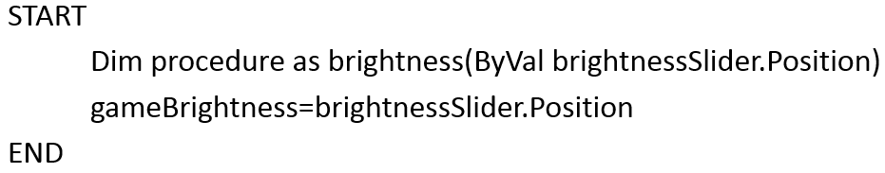

I have created this procedure so that the users will be able to control the brightness of the game instead of changing their brightness on their whole screen. The pseudocode above shows that ‘brightness’ has been declared as a procedure by value, and whatever brightness that the user has chosen, it will assign it to the variable ‘gameBrightness’ and store it there.

**Song & Difficult Selection**

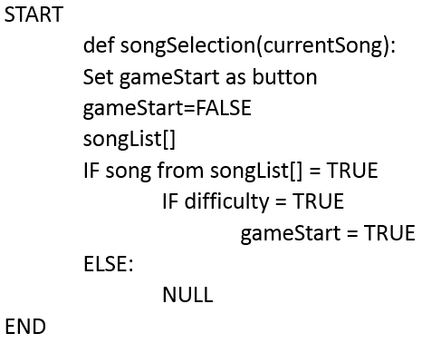

Progressing further towards the main game, the player must choose a beatmap (also known as a song that can be played) before moving onwards towards the main game. This pseudocode that I have designed allows the player to select a beatmap and difficulty by simply clicking on the interactive bars, and by doing so, this will take the beatmap from ‘songList[]’ and check if difficulty has also been chosen, if both of these conditions are met, ‘gameStart’ will be declared as TRUE therefore allowing the player to start the game.

**Score**

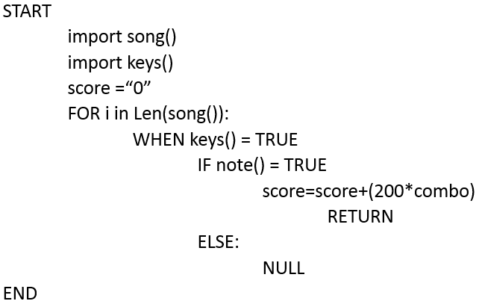

Once the game starts, the player will have a score, and this score will determine the grade that they will get at the end of the match. Depending on what the score and accuracy they get overall will give them a grade from ‘A’ to ‘D’. Their score will start at ‘0’ then the code will find out the duration of the song and enable the keys() for that amount of time. When the player hits the notes with the keys, the score will increase by (200*combo) which will be returned back to the score.

**Accuracy**

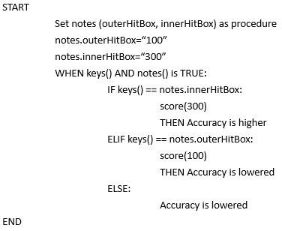

For the Accuracy pseudocode, I have included two hitboxes for the notes in order to determine the accuracy for the players; inner hitbox and outer hitbox. If the timing of the player’s keys are off timing, it may land outside of the note causing the player to miss the note therefore losing accuracy and points, however, if he lands at least within the outer hitbox, he will gain at least 100 points excluding the combo multiplier, but their accuracy will still be lowered as they will not have landed the hit perfectly at the right time. If the player lands the hit perfectly on the inner hitbox, then they will be rewarded with a higher accuracy (if they are already on 100% accuracy then it will stay as 100%) and a higher score.

**Combo Multiplier**

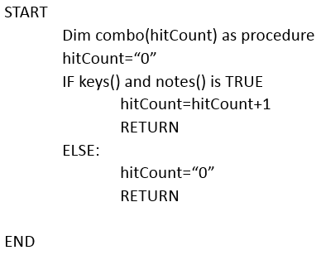

When the main game starts, the player will be supplied with a combo multiplier and this is determined by how many notes they can hit without failing. I have created a procedure that is named ‘combo’ and a parameter that is called ‘hitCount’. When the player has made contact with the notes with the keys, the hit count will be increased by 1, however if it does not make contact, the hit count will be reset back to 0 therefore their multiplier will be gone and they will have to re-build it.

**Health Bar**

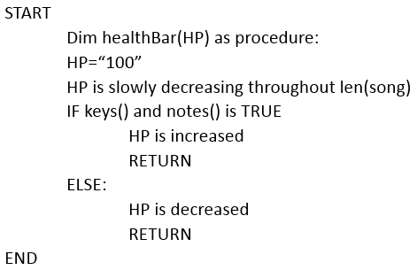

For most games, there will be a health points bar available and for mine, there will also be a health points system. I have decided to design a pseudocode that will be fit for my game. Right above you will be able to see that I have created a procedure named ‘healthBar(HP)’, the parameter ‘HP’ will be passed in as a variable which will have a value of “100” assigned to it. Throughout the whole song, the player’s HP will be steadily decreasing at a specific rate therefore forcing the player to hit at least a specific amount to be able to survive through the whole song and by doing that, the player must be able to land a hit on the notes by using the assigned keys which will increase the player’s current amount of HP by returning the value back to its parameter. Else if the player misses the note, their HP will decrease which will also be return the value back to the parameter.

**Timer**

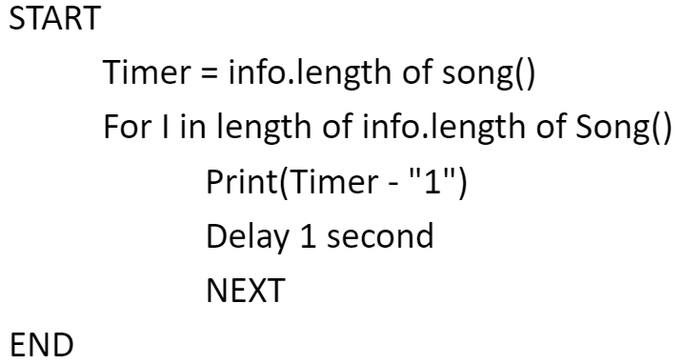

To show the player the remaining time left, I have created a pseudocode that will give an idea of how it would work, on the second line of the code, I have created a variable called ‘Timer’ which gives us the length of the song and by having this, I can create a FOR loop that will print out the remaining time left each after each second has past.

**Keys**

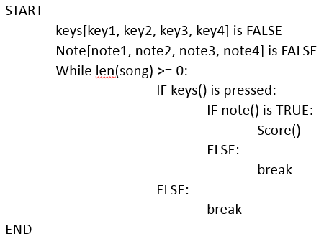

The point in this pseudocode is that it will be used for the player’s interactions with hitting the notes with the keys that they have already set up beforehand, if they haven’t then the keys will be the same as the default. This code will run until the while loop is proven to be false which is when the song ends. If the player clicks on the keys, then it will be followed up with another if statement which will check whether the note was interacted with or not, then that note() function will decide whether it was or not and if it was then the score will be increased. After that, both if statements will break and the while loop will restart.

## Test Data for Development

**Home Screen Buttons**

|  |  |  |  |  |  |
| --- | --- | --- | --- | --- | --- |
| TEST | VALID DATA | EXPECTED OUTCOME | INVALID DATA | EXPECTED OUTCOME | Justification |
| Does the button ‘start game’ work on the home screen? | ‘Start Game’ button clicked with the mouse button | Loads the next screen that will allow the player to select their song and difficulty | ‘Start Game’ button was not clicked with the mouse button | The screen does not change, it will stay on the same screen until the player clicks on a valid button. | It is important to test whether the button works or not otherwise the player will not be able to start-up the game. |
| Does the button ‘leaderboards’ work on the home screen? | ‘Leaderboards’ button clicked with the mouse button | Loads the next screen that will allow the player to look at the current rankings | ‘leaderboards’ button was not clicked with the mouse button | The screen does not change, it will stay on the same screen until the player clicks on a valid button. | If the button does not work for leaderboards, the players will not be able to check the current rankings of the top players. |
| Does the button ‘settings’ work on the home screen? | ‘Settings’ button clicked with the mouse button | Loads the next screen that will allow the player to change the settings of the game such as volume, key bindings and screen | ‘Settings’ button was not clicked with the mouse button | The screen does not change, it will stay on the same screen until the player clicks on a valid button. | This test is to ensure that the settings button works otherwise they will not be able to change anything to suit their needs. |
| Does the button ‘exit’ work on the home screen? | ‘Exit’ button clicked with the mouse button | Loads the next screen that will allow the player to verify that they are exiting the game | ‘Exit' button was not clicked with the mouse button | The screen does not change, it will stay on the same screen until the player clicks on a valid button. | If the exit button does not work then the player will have difficulties exiting the game as they will need to exit it directly on task manager. |
| Does the button ‘login/signup’ work on the home screen? | ‘login/signup’ button clicked with the mouse button | Loads the next screen that will allow the player to either log in or sign up to the game. | ‘Login/signup’ button was not clicked with the mouse button | The screen does not change, it will stay on the same screen until the player clicks on a valid button. | The purpose of testing this is that the player must be able to login/signup to the game so that they are playing on their profile. |
| Does the button ‘exit(yes/no)’ work on the home screen? | ‘exit(yes/no)’ button clicked with the mouse button | Allows the player to click either yes/no, if yes then the game will automatically close itself. | ‘Exit(yes/no) button was not clicked with the mouse button | The screen does not change, it will stay on the same screen until the player clicks on a valid button. | This is to ensure that the confirmation buttons work so that the player can exit the game. |

**Rankings Screen**

|  |  |  |  |  |
| --- | --- | --- | --- | --- |
| TEST | VALID DATA | EXPECTED OUTCOME | INVALID DATA | EXPECTED OUTCOME |
| Does the rankings screen display the number of players and scores? | Rankings page will be loaded up after clicking on the ‘leaderboards’ button | Scores will be displayed on to the screen for the player to see. | Leaderboard button was not clicked on. | Screen stays the same and does not load up scores and usernames. |
| Does the ‘back’ button work? | Clicks on the ‘back’ button | The player will be returned to the previous screen. | The player did not click on the button. | The player will stay on the current screen that they are on. |

**Settings Screen**

|  |  |  |  |  |  |
| --- | --- | --- | --- | --- | --- |
| TEST | VALID DATA | EXPECTED OUTCOME | INVALID DATA | EXPECTED OUTCOME | JUSTIFICATION |
| Can the player change the display mode? | Clicking on either windowed or fullscreen | The display mode changes to the specified screen | Clicks on something else on the screen | Nothing will happen or change. | This is so that the player can change the display mode and play the game comfortably. |
| Can the player change the key bindings to something else? | Clicking on the key bindings and clicking on another key to change it. | The default button ‘S’ can be changed to ‘Q’. | Changing a key binding to a function button | The program will reject this key. | This is so that the players can change their keys if needed to. |
| Does the scroll work on volume? | Dragging the scroll button left or right. | The volume will change accordingly | The scroll key will go over 11. | The player will be unable to go higher than 10. | This is to ensure that the volume is not too low/high for the player |
| Does the scroll work on brightness? | Dragging the scroll button left or right. | The brightness will change accordingly | The scroll key will go over 11. | The player will be unable to go higher than 10. | This is to ensure that the brightness is not too dim/bright for the player. |

**Song Selection Screen**

|  |  |  |  |  |  |
| --- | --- | --- | --- | --- | --- |
| TEST | VALID DATA | EXPECTED OUTCOME | INVALID DATA | EXPECTED OUTCOME | JUSTIFICATION |
| Can the player select a song using the button? | Clicking on a song | The song will be highlighted suggesting that it has been selected | Clicking the screen | Nothing will happen | By testing this button, it will ensure that the user will be able to select a song they want to play. |
| Can the player select a difficulty of the song using the button? | Clicking on a difficulty | The difficulty will be highlighted suggesting that it has been selected | Clicking using the mouse button 2 | Nothing will happen | This is so that the user can play a difficulty that will match their skill level. |
| Does the ‘back’ button work? | Clicks on the ‘back’ button | The player will be returned to the previous screen. | The player did not click on the button. | The player will stay on the current screen that they are on. | If the back button doesn’t work then the player will not be able to go back to the previous page which is why it needs to be tested |
| Does the ‘Start’ button work? | Clicks on the ‘start’ button after selecting a song and difficulty | The player will be directed to the main game | The player did not click on the button. | The player will stay on the current screen that they are on. | If the start button does not work, then the player will not be able to load the game up. |

**Main Game**

|  |  |  |  |  |  |
| --- | --- | --- | --- | --- | --- |
| TEST | VALID DATA | EXPECTED OUTCOME | INVALID DATA | EXPECTED OUTCOME | JUSTIFICATION |
| Do the notes drop down from the top of the screen? | Load game form | Player will be transferred to the main game with their chosen song | Load menu form | Player will be loaded up with the main menu instead of the actual game | This needs to be tested because it allows the player to react. |
| Does the score increase with each note being tapped on? | Player uses the right keys to tap the notes | Score will increase | Player clicks on the notes with the wrong keys | Player’s score will not increase | If the score does not increase with every hit on the note, then there is an bug that needs to be corrected. |
| Does the user’s health decrease throughout the game? | Play the game | Their player’s hp will be slowly decreasing | Paused game | Player’s hp will not decrease | This is so that the player will get punished if the player does not do anything. |
| Does the player’s combo increase? | Player hits the notes with keys | Combo increases depending on if it lands | Player clicks on the wrong key | Combo will reset back to normal | This needs to be checked because, this is the multiplier that will increase the player’s score. |
| Does the time duration decrease? | The game begins after song selection | Timer should show how much longer is left until the end of the song | The game begins after song selection | The timer displayed does not change at all | By having this, the player will know how much time he will have left |
| Does the user’s accuracy percentage change? | After each hit on the notes | Player’s hit accuracy will vary depending on if the player has landed the hit or not | After each hit on the notes | Player’s hit accuracy does not change | The user’s accuracy must change in order for the user to have an accurate score at the end of the game. |
|  |  |  |  |  |  |

## Testing Data for Robustness

***Hiding forms from users***  
The first test that must be tested on would be the forms being hidden from the users. For example, when the Settings button has been clicked on, the Settings page should appear, and the previous page should be hidden away. This test is used to prevent the user from being able to go back and possibly crashing the game.

***Keeping usernames within the textbox***  
Whenever the users type in their name into the text box, the user may face problems such as having a name that may be too long therefore stretching out of the range of the textbox. This problem can be prevented by limiting the amount of characters that the user can type in for example, 1-16 characters will be the range that the users can type in their name for the leaderboards, if the user types in anything less or more than the required value, an message will popup, mentioning that the name is invalid.

***Interacting with notes using keys other than specified ones***  
A may problem that may occur is that the player may be able to interact with the notes using random keys which will cause a problem for my game. This can be prevented by ensuring that the code only registers the specified keys that has been assigned in the settings page.

***Incorrect song is being played***  
This could be a slight problem because the game may load up a different song to what the player has chosen, therefore I must ensure that the code is designed to only load up the correct songs when chosen.

***Leaderboard may not save scores***  
Another problem that may come up is when the player tries to save upload their highscore on to the leaderboard. When they have typed in their name for the leaderboard, they must click ‘save’ otherwise their score will not save. I can ensure that they do not click of the screen by only allowing the user to have two options before proceeding to the next screen, this is to allow an option that will enable the user to not upload their highscore. One of the options must be clicked on before they can move on.

***Controls on game screen***  
To avoid this simple problem, I will place the controls that has been currently chosen on the game screen, this is to show and allow the players to remember what the controls were set as. Not only that, the key will change colours on screen to show that the key is being pressed to show the player that it is responsive and working.

## End User Survey

**Questions**

1. ***Is the navigation system in the game simple to use?***  
   Yes/No  
   If ‘No’, please explain why:

By gathering results of whether the navigation is simple to use or not, will allow me to decide on what functions and features to change and implement into the system therefore creating a better product by the end of the production.

1. ***Do the difficulty options help you enjoy the game?***  
   Yes/No  
   If ‘No’, please explain why:

If the difficulty options help the player enjoy the game, then that means that it will be ideal to keep it in the game as the players will prefer having them in the game.

1. ***Are the frames being displayed smoothly?***  
   Yes/No  
   If ‘No’, please explain why:

If the frames are not being displayed smoothly, then I will need to lower down the specifications for this game as the audience must be able to enjoy it with a smooth gameplay as this also affects their experience with the game.

1. ***Does the game help improve your reaction speed?***  
   Yes/No  
   If ‘No’, please explain why:

By asking this question, it will mean that this game can be used to help polish their reaction speed in order to play on a harder difficulty therefore making the game even more fun to play on.

1. ***Is the start-up of the game slow or fast for your computer?***  
   Yes/No  
   If ‘No’, please explain why:

If the start-up of the game is slow then it will be annoying for the users as they will need to wait a tedious period of time before the game has been completely loaded.

1. ***Are the buttons in the game responsive?***  
   Yes/No  
   If ‘No’, please explain why:

By knowing whether the buttons in the game are responsive or not, this will allow me to know whether I will need to change any of the code so that the players can run the game smoothly without any interruptions.

1. ***Do your settings save correctly?***  
   Yes/No  
   If ‘No’, please explain why:

If the settings do not save correctly then they will have trouble playing the game as they are not comfortable with the default settings therefore the game is bugged and it must be debugged immediately so that the players are able to play within their own comfort zones.

1. ***Is the game engaging and fun?***  
   Yes/No  
   If ‘No’, please explain why:

By seeing if the game is engaging and fun or not, I will be able to change some parts of the functionality in the game so that the players are able to enjoy it.

1. ***Would you play this game often if it was to be released?***  
   Yes/No  
   If ‘No’, please explain why:
2. ***Are you likely to recommend this game to other people?***  
   Yes/No  
   If ‘No’, please explain why:

These questions will be given to the end-user in the form of a survey once the final prototype has been completely developed. This will provide me with more useful information which will allow me to improve my game and implement more features.

## Development of the Coded Solution

## **Creating interactive buttons**

For my game; Tapmania, I have gathered and list of assets that I will be using for my game, these were found on the internet as I am not able to create all of it myself since it will be consuming too much time which could be used on creating the actual game. These assets that I have found are all free of copyright, so I do not need to worry about owners of the original product, copyright striking my game for using their products.

First of all, I have taken the assets that are logically named ‘buttons_(colour)’ and placed it into the main scene of my game by dragging the images into the ‘Main’ window, so that the players are able to see them on the screen, I have also created a folder named ‘buttons’ so that I am able to easily locate the buttons whenever I need to amend any settings related to the buttons in, I was able to do so, as I was thinking ahead, which lead to many possibilities that I have to consider.

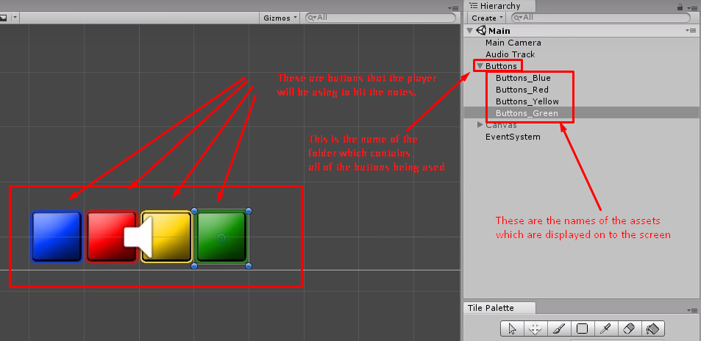

Furthermore, I have mentioned in the requirements section that my game will fit to a screen resolution of 1920x1080, therefore I have purposely scaled the background and buttons to fit the screen and have them to look normal for the player.

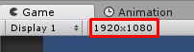

After placing the buttons on to the screen and sorting them into a folder named ‘Buttons’ as this will be a sensible thing to do since I will know where the buttons are located in, I will need to create a C# script in the assets folder that will allow the players to interact with the buttons when hitting the notes. I have named this script ‘ButtonController’ because this script is solely used to program the buttons and nothing else, this is a separate class that is going to be used for this game.

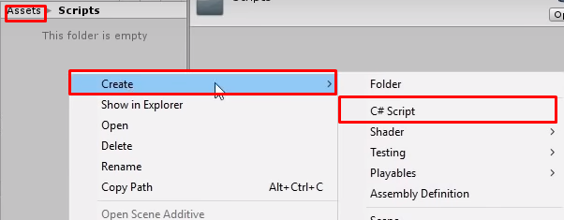

After creating the script for the buttons, I will open the file on visual basics which will allow me to edit the source code within the script. Firstly, I have created variables that will be needed for the buttons to be functional, these includes the ‘theSR’, ‘defaultImage’, ‘pressedImage’ and ‘keyToPress’. The sprite renderer is assigned to the buttons on Unity so that the sprites can be used. Secondly, the keyCode is called so that the user will be able to choose what buttons on the keyboard to assign the buttons to, this will lead to the bottom part of the code, I have created an IF statement so that when the assigned key is pressed, the sprite will be changed to the ‘pressedImage’ by using the sprite renderer, and when they key has been lifted back up, the sprite renderer will replace ‘pressedImage’ with ‘defaultImage’

**C# script to control buttons:**  
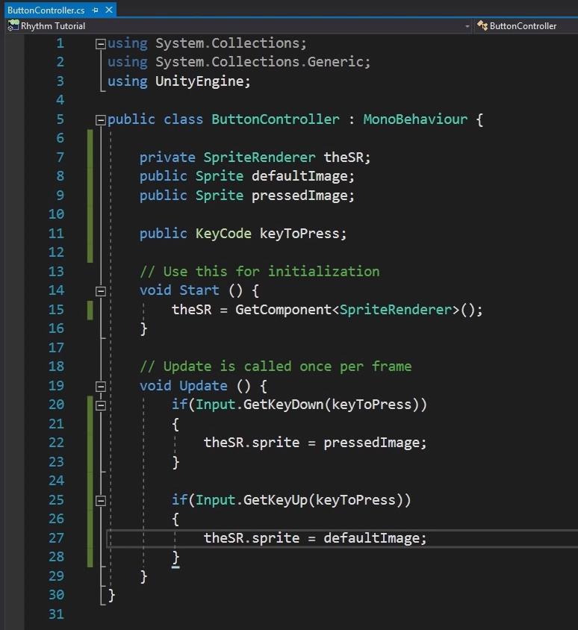

As you can see below, I have saved the script and went back to Unity it was able to compile all of the code that was written on to the system as you can see that ‘Default Image’, ‘Pressed Image’ and Key To Press’ has been added in to the settings. After that, I am able to drag and drop each image into its own correct slot and I will be able to assign each button to ‘S, D, J and K’ accordingly.

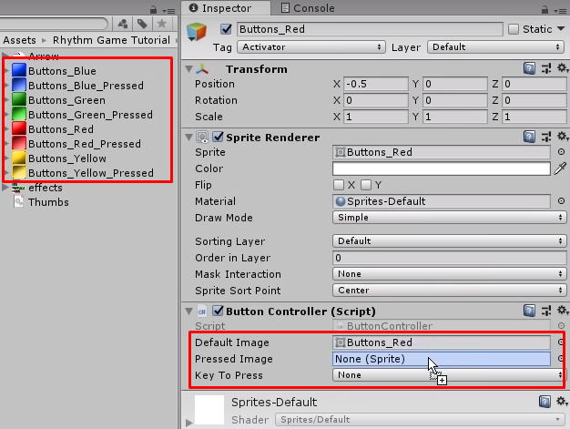

Now that I have assigned the buttons with a key and image, I have tested it out by clicking on to the buttons that I have assigned them to which are ‘S, D, J and K.’ If the buttons are working, then it should display a different image to show that it has been clicked and is functioning normally. If the button is not functioning, then there must be an error within the code itself. I clicked on the buttons multiple times and each of the images were changed from ‘Default Image’ to ‘Pressed Image.’ For example, the image below shows the transformation of the yellow button which proves that it works.

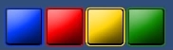

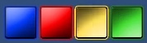

## **Adding in interactive Notes with beats**

In the image below, you will be able to see a section within Unity that states ‘Tags & Layers’, this feature in Unity allows objects to be layered on top of each other, for example, an object may appear on top of another, but you can change that by setting the object to a layer higher than that, so that it will be able to see it. I have used this method to assign my notes to a higher layer using the ‘Sorting Layer’ function, so that it will not be under my buttons when they slide down as the players will find it difficult to look at. The reason why I did not do the same for my actual buttons is because there is no need as they are assigned to the default layer when created and they are not needed to be on top of the arrows or anything else.

**Images show how I have placed the note on to a higher layer with evidence when running:**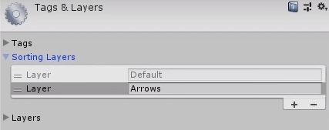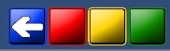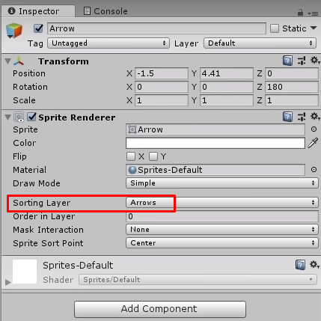

Furthermore, after finishing designing my buttons and being able to make it functional and working properly, I will now need to program the notes in a way that the player will be able to interact with them as they must be able to hit them allowing them to score points in the game itself, and by enabling the players to do that, I have created another script that belong to the notes which is named ‘BeatScroller’, this is so that I will note what this script belongs to. In these lines of codes, I have firstly created a public float which is called ‘beatTempo’, this will decide how fast the notes will be falling down therefore I will be able to use this to suit the rhythm of the song. I have also created a public boolean to check whether the game has started or not. After creating them, further down the code, you will be able to see in void Update(), I have created an IF-ELSE statement to check whether the user has clicked on a key or not, this programming construct; selection will enable the player to start the game by clicking any key on the keyboard. After checking to see whether a button has been clicked or not, the code within void Update() will run again to see if anything has been changed, and for example, if the player has already clicked on a button, then the notes will start falling down by using the transform.position function. I have used only the Y-axis to move the notes at the rate of the beatTempo as the notes shouldn’t be moving anywhere else apart from the positions within the Y-axis.

**The C# script for the scrolling of the beat:**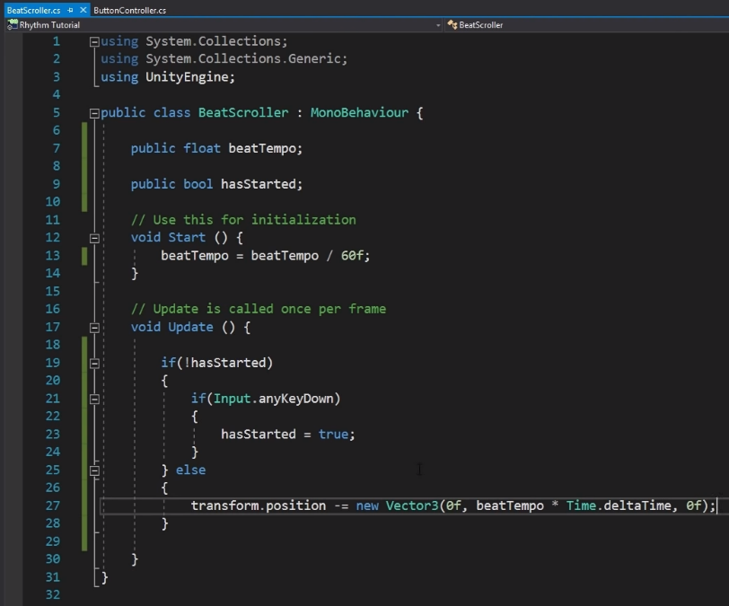

In the code below, I have created another c# script that will allow the notes to become ‘clickable’ when it enters the button zone for the player. Firstly, I have created a onTrigger2D which will be able to identify when the note has been hit by the buttons. If the activator tag has been hit, the Boolean ‘canBePressed’ will be set as ‘True’ therefore allowing the note to be hit. Then I have copied the sub-procedure and re-wrote parts of the code so that the activator is false instead, this will allow the button to exit from the state of being already pressed.

**The C# script to show how the button is being toggled:**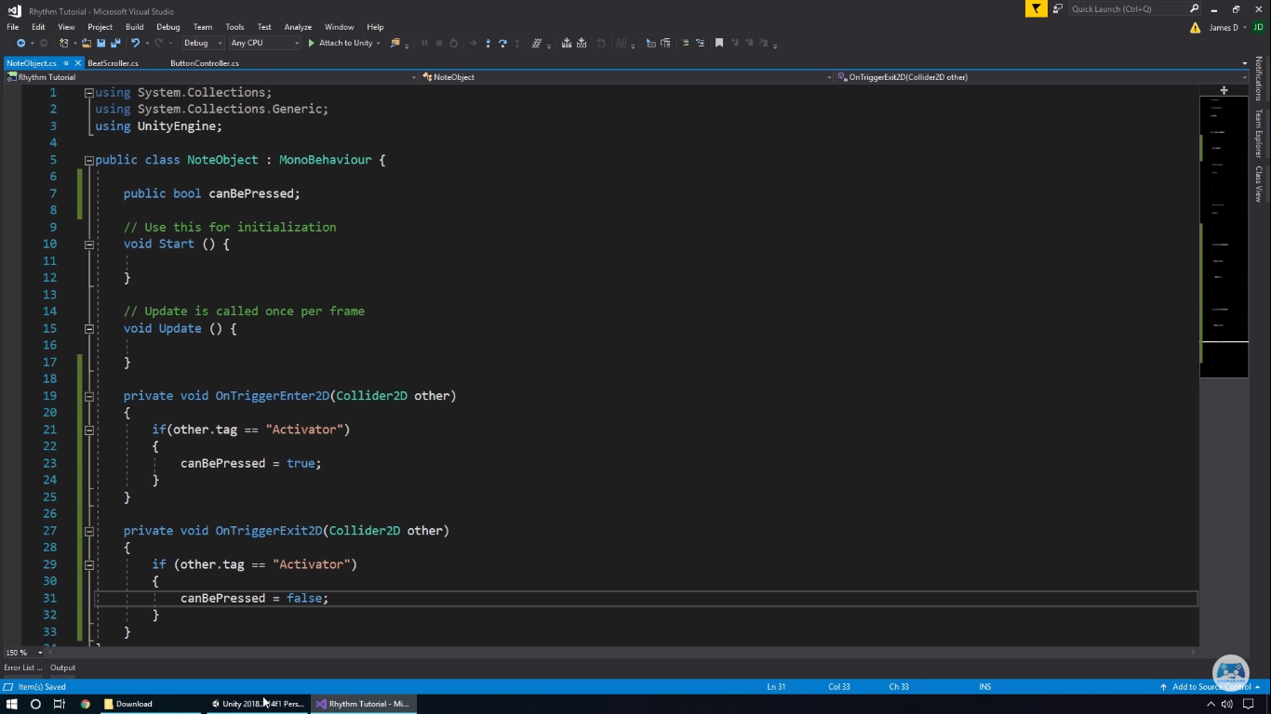

Ok, so after creating that script for the buttons to trigger the notes. I need to add in a box collider 2D and enable the ‘on trigger’ which will allow the buttons to hit the notes, I have then adjusted the hitboxes for the box collider so that they are fitted inside of the buttons rather than being oversized which will be illogical to do so. After adding that in, a rigid body is needed for each button so that each of them will be able to detect when the notes are entering the hitbox.

**Here is an image that shows where I have added in the Box Collider and Rigid Body:**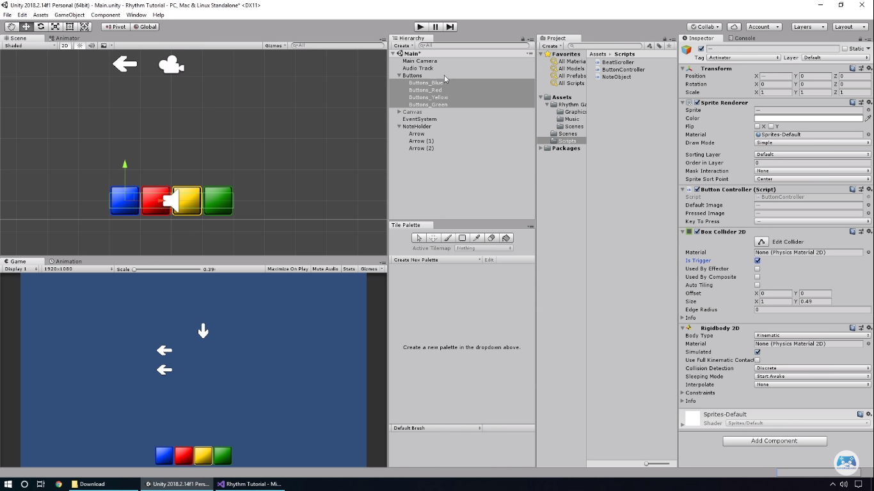

After adding those necessary components to my buttons and notes, I have went back into my NoteObject script and updated the code. As you can see, I have added in a button controller. On each individual arrow, they will have a public key code that will is assigned as ’keyToPress’. Therefore if the boolean ‘canBePressed‘ is ‘TRUE‘, then the object (the arrow) is in the right position in the game, then the ’gameObject’ is set to false so that I am able to test to see whether it is working or not.

**This is the updated code for Note object:**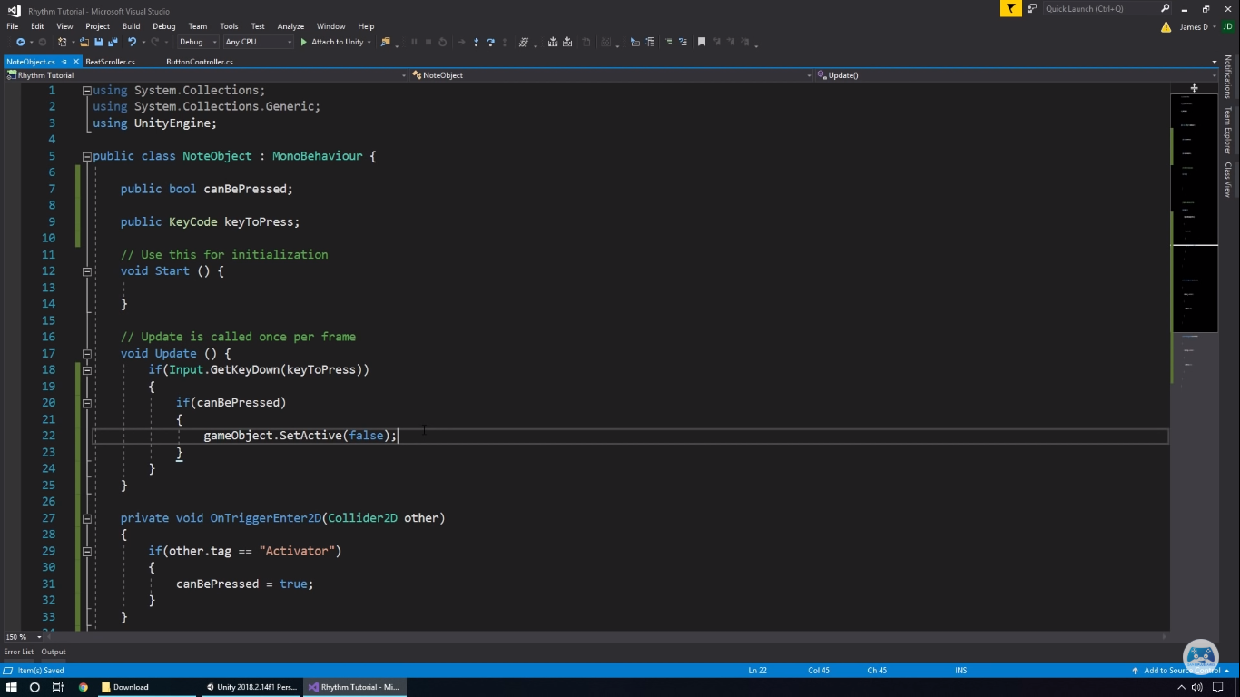

Right after compiling the c# script, I have assigned each arrow to its rightful key. I have assigned the Left arrow as ‘S’, Up arrow as ‘D’, Down arrow as ‘J’ and Right arrow as ‘K’. I have done this because this will allow the players to use their dominant fingers which will allow them to react and easily control each key as fast as possible.

**Assigning keys for each note:**  
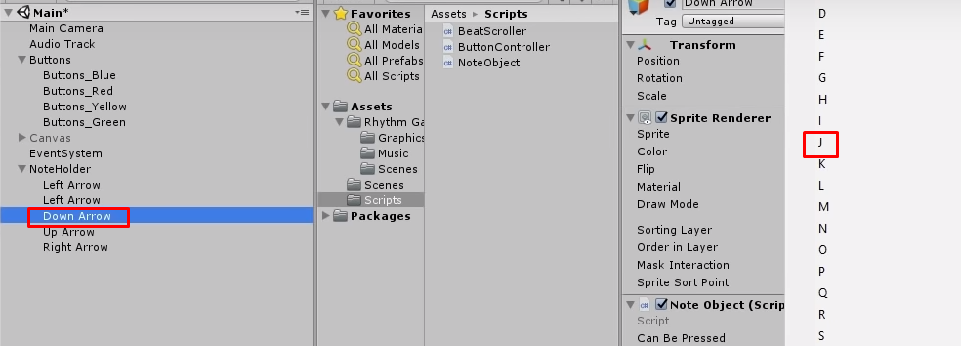

**Here is a before and after to show that the notes can be clicked on:**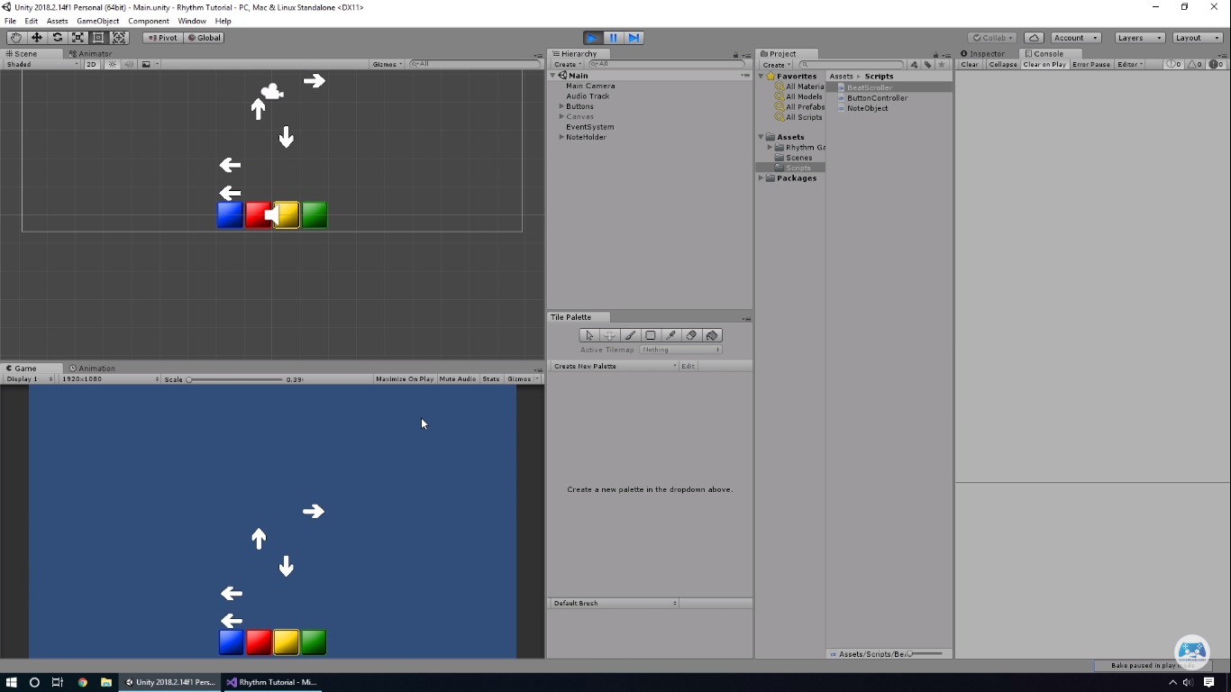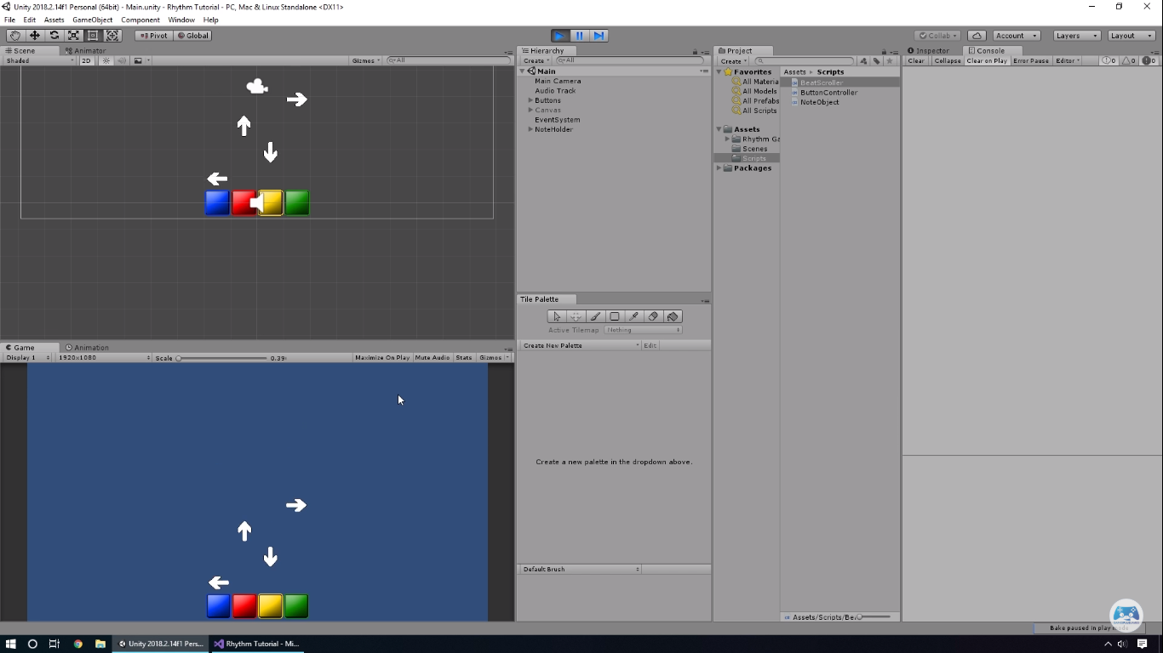

## **Adding Music to the Game**

**Creating a new C# Script to manage the game (music, start and end):**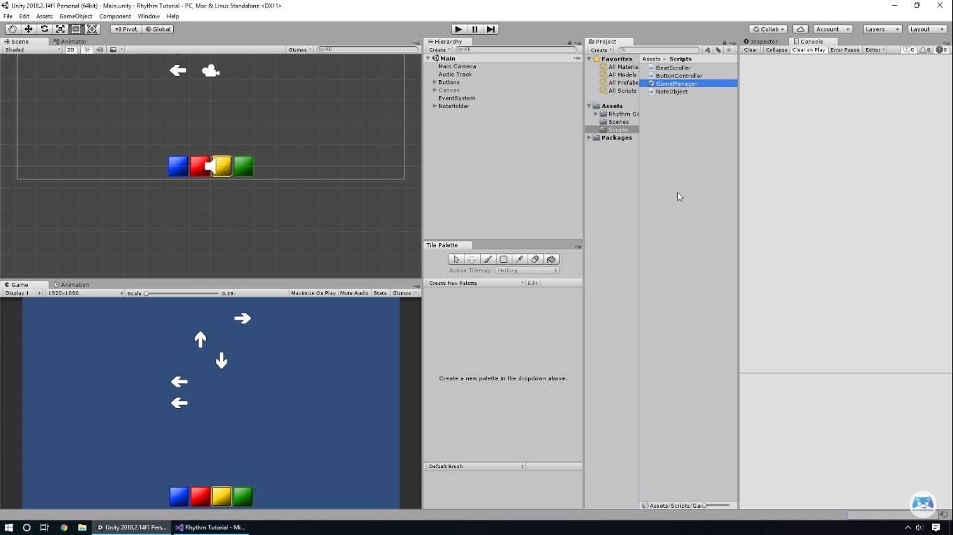

Firstly, in the script below, I have added in a public AudioSource that will be called theMusic as it would be easily identified if I were to make any changes to it in the later prototypes. Then I created a Boolean that will decide when the music and game starts playing. Then finally I also added in a beatScroller which will decide when the notes will start scrolling down along with the music.

**C# Script of Game Manger:**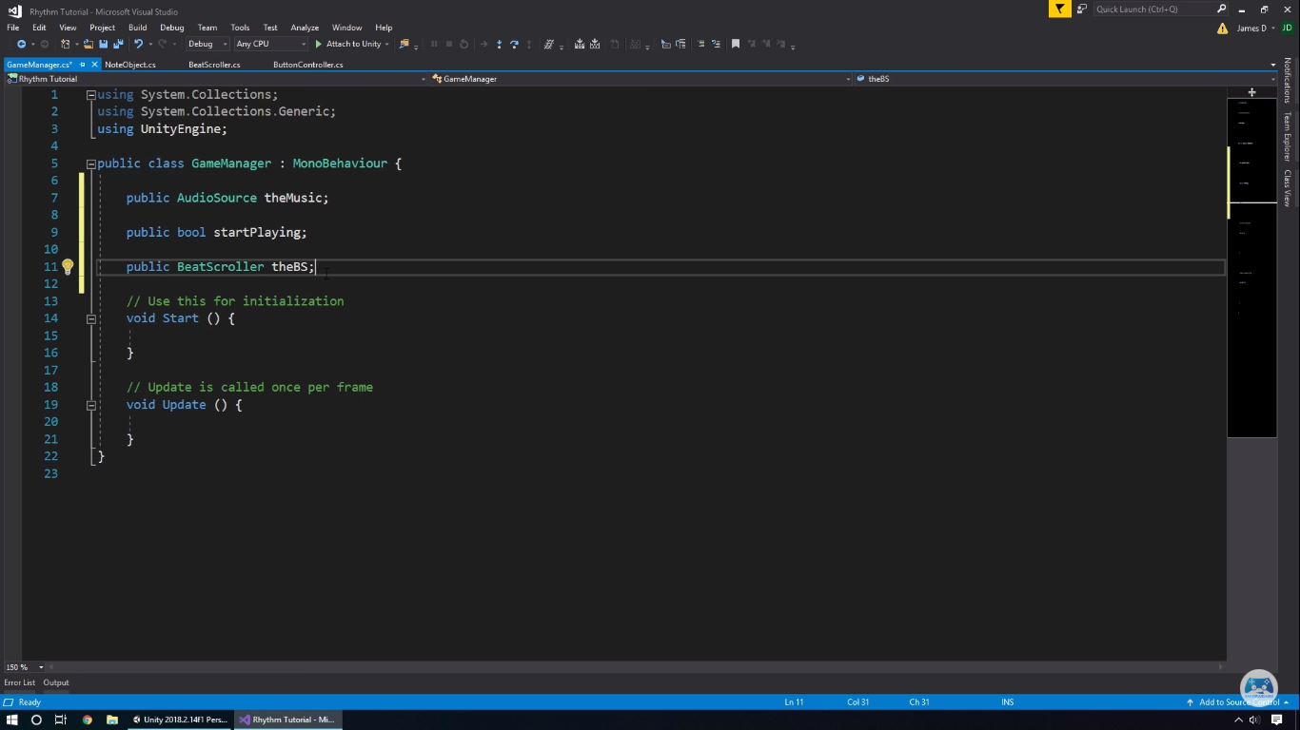

After creating the script, I have gone back into the main game and added in a new object and drag and dropped the script into the Game Manager object so that it will have the access to the attributes that I have coded into it. On the right, you will be able to see that I am able to drag and drop the music that I have chosen into it. Then I will be able to drag and drop the folder named ‘NoteHolder’ into the beat scroller so that they will start scrolling when the song plays.

**Creating a new object and adding in the script to it:**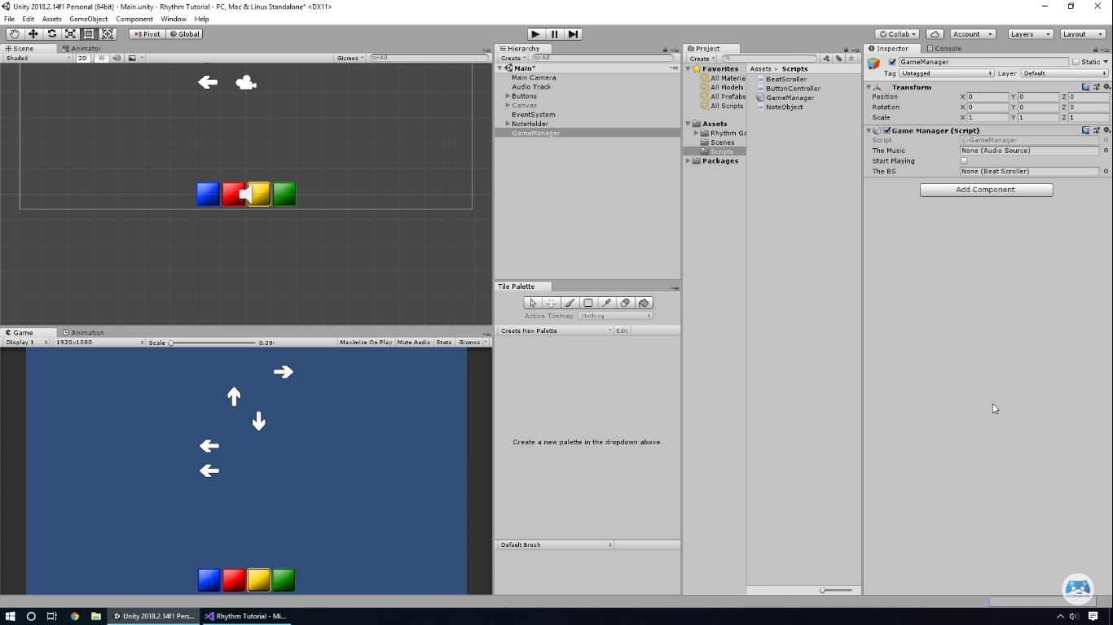

In this script, I have added in an IF statement in void update to set ‘startPlaying’ to false by default, then I created a nested IF statement inside the current one, I have done this because this will check whether the player has pressed any keys down on their keyboard and if they have, startPlaying and beatScroller will be set to True and the game will start playing along with the music and beat scroller.

**Updated C# Script of Game Manger:**